**DATA DRIVEN APPLICATION WITH R**

**FINAL PROJECT**

**“Analysing and Forecasting COVID -19 Cases ”**

**-Ashish Pal**

**-Parvez Gundumalli**

**-Shraddha Shinde**

**Analysis and Forecasting of COVID-19 Cases**

This project is about analysing the data for Covid-19 cases for the country USA and on basis this data we are predicting the trends for next 28 days and also checking the prediction statically.

Firstly we started by importing libraries like **covid19.analytics**(for fetching worldwide data of Covid19 Cases),**dplyr**(for data Manipulation),**prophet**(predict and forcaste),**lubridate**(A tool to parse and manipulate dates),**ggplot2**(Data Visualisations).

**Steps:**

1)DATA STORING: We are fetching data from covid19.analytics library and storing those data in variable named “DATA”.

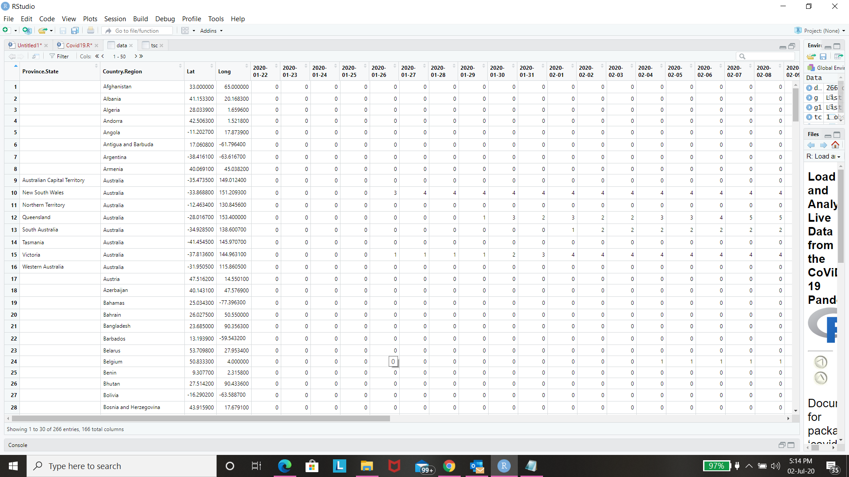

2)FILTERING: Now fetching data for particular country (USA) using filter function.

3)CLEANSING: Removing unwanted rows and changing the column names to date type using column bind(**CBIND function**).

4)Now we have two columns namely “DATE” and “CONFIRMEDCASES”.

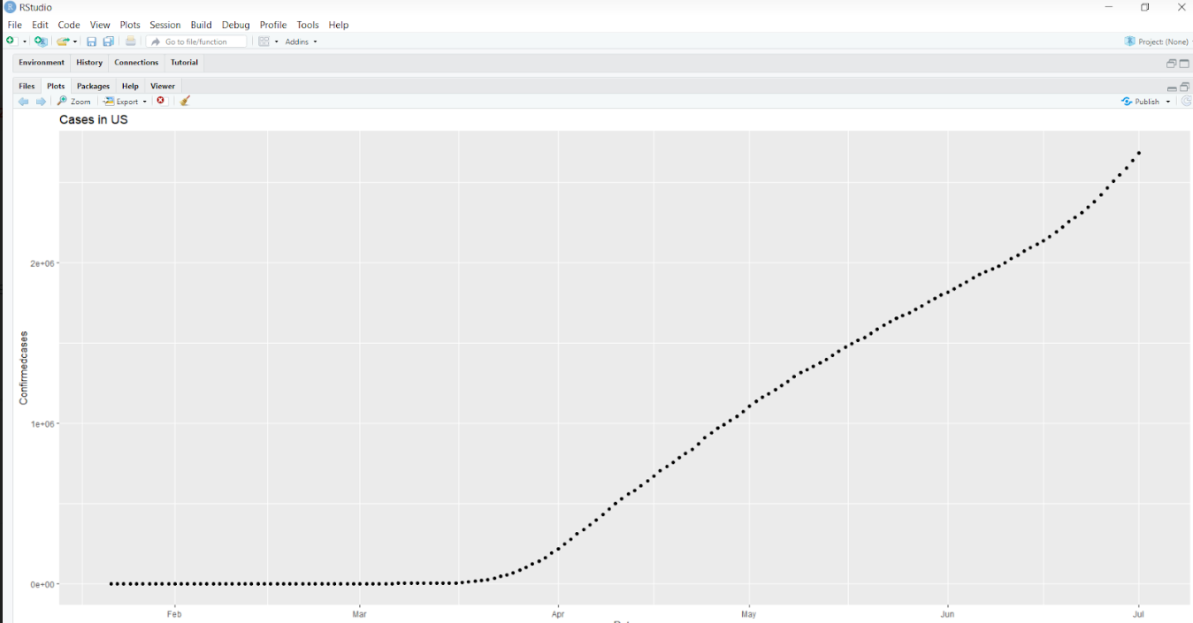

5)Changing the date format from Character to Integer type and also we can check the structure using **str() function**.

6)Plotting two columns “date” and “confirmedcases” using qplot function.

7)Now creating data frame using **data. Frame()** and passing two arguments .

8)Finally we are forecasting covid19 cases using **prophet() function**.

9)To predict upcoming Covid 19 cases for next 28days.

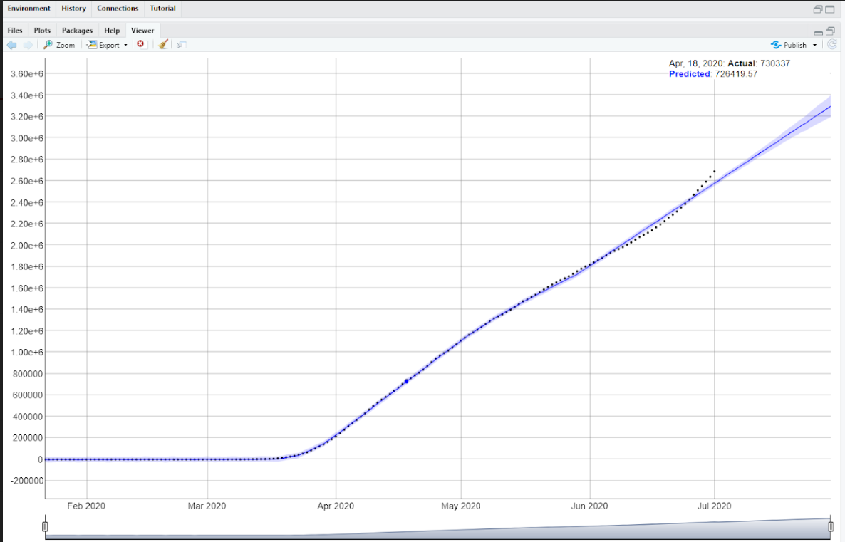

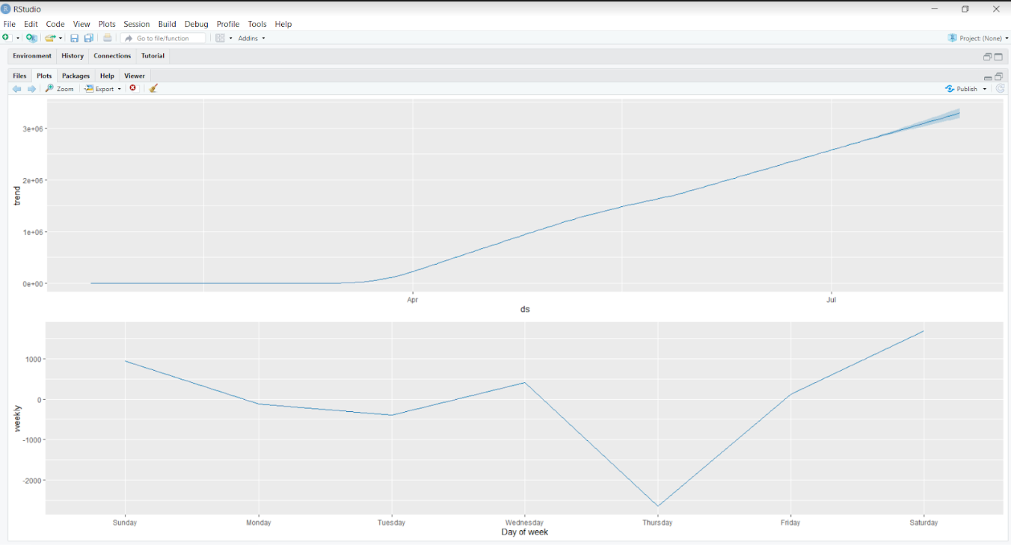

10)Summary: Checking the prediction with actual data statistically using summary() function.

